

WACHEMO UNIVERSITY ENGINEERING AND TECHNOLOGY DEPARTMENT OF INFORMATION TECHNOLOGY
COURSE TITLE FUNDAMENTALS OF DATABASE
Group members ID
1,Bruki Tedesse....... .............................................................................. 172717
2 Cherinet Tessema................ .............................................................. 170972
3,Derebe Zeleka ................................................................................... 176064
4,Henok Brihanu...................................................................................... 176534
5,HIkima Mohammed................................................................................ 171637

Project Title
Wachemo University Students Clinic Management System
Introduction
This database system is designed to digitize the daily operations of the Wachemo University Student Clinic.
The importance of a digital health record system for university clinics.
- The purpose: To store, manage, and retrieve student/staff medical information efficiently.
- Benefits: Reduces paperwork, speeds up service, ensures accurate prescriptions, tracks medicine stock, etc.
- Mention Wachemo University’s student population and need for organized health services.
The system manages student registration, medical history, laboratory tests, and pharmacy dispensing.
Its primary goal is to reduce paperwork and provide fast, accurate medical services to students.
Problem Description
Describe what the current system lacks (e.g., manual records, slow retrieval, no central database).
**Users:**
- Students/Staff (Patients)
- Doctors/Nurses
- Clinic Administrators
**Data stored:**
Patient details,visits, diagnoses ,prescriptions,inventory, appointments.
Problems solved:
1. Manual record-keeping errors.
2. Difficulty in tracking patient history.
3. Poor medicine inventory management.
4. Long appointment wait times.

* What the system is about: The system is a data management tool for the university clinic's workflow.
* Who uses it (Users): Receptionists (Card Office), Doctors, Laboratory Technicians, and Pharmacists.
* What data is stored: Student identities, medical records (diagnosis), laboratory results, and medicine inventory.
* What problems the database solves: It prevents the loss of paper files, allows for quick retrieval of patient history, and helps monitor pharmacy stock levels.
Objectives
List measurable goals:
1. Design a secure, normalized relational database for the clinic.
2. Enable easy appointment scheduling.
3. Maintain patient medical history.
4. Manage medicine stock and expiry dates.
5. Generate reports (daily patients, stock levels, doctor schedules).

* To organize student information in a centralized database.
* To simplify communication between doctors and patients.
* To link laboratory and pharmacy workflows directly to the patient’s file.
* To generate medical reports easily.
Scope of the Project
Included
The project includes student registration, diagnosis, laboratory services, and pharmacy management.
- Patient registration (students/staff)
- Appointment management
- Medical visit recording
- Prescription & inventory management
- Basic user roles (Doctor, Nurse, Admin)
Exclude
It excludes external referral clinical processes and staff payroll management.
Laboratory management
- Multi-branch clinic support
Requirements Analysis
Based on the guideline requirements for entities, attributes, and relationships:
Entities & Attributes:
* Student: StudentID, FullName, Gender, Department, Dorm_Number, Phone.
* Doctor: DoctorID, Name, Specialization, Working_Shift.
* Medical_Record: Record ID , Date, Symptoms, Diagnosis.
* Lab_Test: LabID, Test_Type, Result, Lab_Technician.
* Medicine: DrugID, Drug_Name, Expiry_Date, Quantity.
Relationships:
* Student -to- Record: One-to-Many (A student can have multiple medical visits).
* Doctor -to- Record: One-to-Many (A doctor can treat many students).
* Record -to- Lab: One-to-One/Many (A medical record can trigger lab tests).
* Record -to- Medicine: Many-to-Many (One record can have many medicines; one medicine can be in many records).
ER Diagram (Logic)
The ER Diagram will visualize these Entities (Rectangles), Attributes (Ovals), and Relationships (Diamonds) with their respective cardinalities (1:M)

erDiagram
STUDENT {
int StudentID PK
string FullName
string Gender
string Department
string Dorm_Number
string Phone
}
DOCTOR {
int DoctorID PK
string Name
string Specialization
string Working_Shift
}
MEDICAL_RECORD {
int RecordID PK
date Date
string Symptoms
string Diagnosis
}
LAB_TEST {
int LabID PK
string Test_Type
string Result
string Lab_Technician
}
MEDICINE {
int DrugID PK
string Drug_Name
date Expiry_Date
int Quantity
}
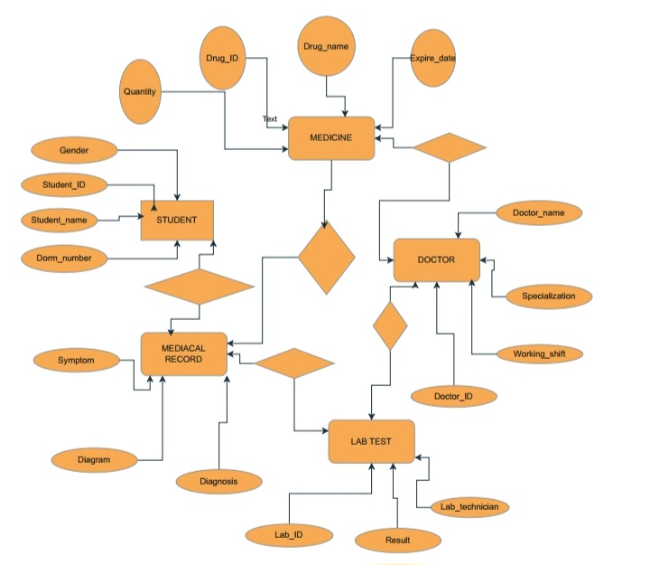

SQL Implementation
-- Database creation
CREATE DATABASE WCU_Clinic_DB;
USE WCU_Clinic_DB;

-- Students Table
CREATE TABLE Students (
StudentID VARCHAR(20) PRIMARY KEY,
FullName VARCHAR(100) NOT NULL,
Gender CHAR(1),
Dept VARCHAR(50),
DormNo VARCHAR(20)
);

-- Doctors Table
CREATE TABLE Doctors (
DoctorID INT PRIMARY KEY AUTO_INCREMENT,
DoctorName VARCHAR(100),
Specialization VARCHAR(50)
);
-- Medical Records Table
CREATE TABLE MedicalRecords (
RecordID INT PRIMARY KEY AUTO_INCREMENT,
StudentID VARCHAR(20),
DoctorID INT,
Diagnosis TEXT,
TreatmentDate DATE,
FOREIGN KEY (StudentID) REFERENCES Students(StudentID),
FOREIGN KEY (DoctorID) REFERENCES Doctors(Doctor

Normalization (Up to 3rd Normal Form)
Normalization is essential to reduce data redundancy and improve data integrity.
* 1st Normal Form (1NF): We ensure that all table cells contain atomic (single) values and there are no repeating groups. For example, a student cannot have multiple phone numbers in one cell; they must be separated or stored in a way that avoids multi-valued attributes.
* 2nd Normal Form (2NF): We ensure the table is in 1NF and all non-key attributes are fully functional and dependent on the Primary Key. For instance, in the Medical_Records table, the Diagnosis depends entirely on the RecordID
.Student table

**1NF (First Normal Form)**
*Eliminate repeating groups - medications*

**MEDICAL_RECORD Table (1NF):**

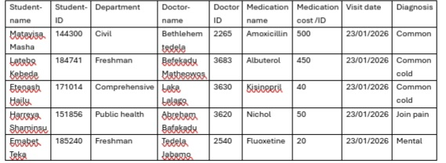

## **2NF (Second Normal Form)**
*Remove partial dependencies - separate entities*

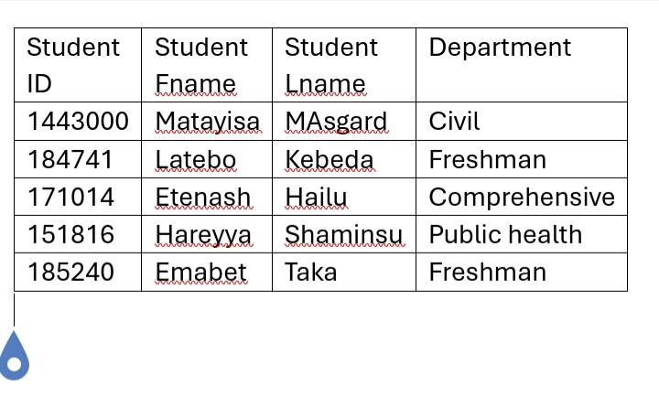
**STUDENT Table:
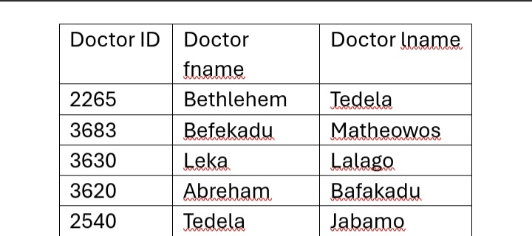
Doctor table name

Medication table

Medication name | Medication cost
Amoxicillin | 500
Albuterol | 450
Lisinopril | 40
Dichlo | 50
Fluoxetine | 20

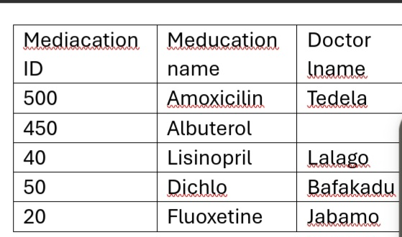
Visit table
Visit ID | Student ID | Doctor ID | Visit date | Diagnosis | Status
V001 | 144300 | 2265 | 23/01/2026 | Common c!ld | Completed
Prescription table

Prescription ID | Visit ID | Medicaion name | Quantity | Duration | Total cost

* 3rd Normal Form (3NF): We ensure the table is in 2NF and remove transitive dependencies. This means a non-key attribute should not depend on another non-key attribute. For example, we separate DepartmentName into a different table so it doesn't depend on a StudentID.

Student :
Student name | Student ID | Department

Doctor table the same 2NF
Department :
Department code | Department name
Civil | Civil engineering
Fresh | Freshman
Comp | Comprehensive
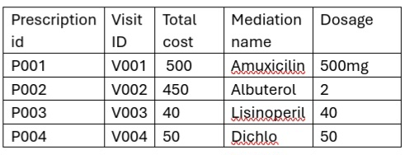
Visit table
Visit ID | Student ID | Dr ID | Visit date | Diagnosis

Prescription table

Complete 3NF Scheme :

Student table

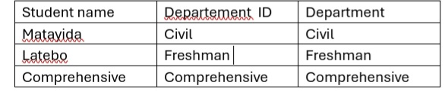
Department table

Department code | Department name
Civil | Civil engineering
Fresh | Freshman
Comp | Comprehensive

Doctor table
Doctor name | Doctor ID
Bethlehem Tedela | 2265
Bafikadu | 3683

Medication tabl
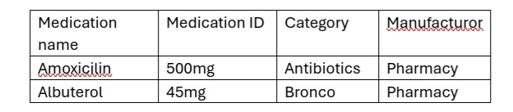

Visit table

Visit ID | Student ID | Doctor ID | Visit date | Diagnosed6 | Status
V001 | 144300 | 2265 | 23/01/2026 | Common c!ld | Completed

Prescription table
Prescription ID | Visit ID | Medicaion name | Quantity | Duration | Total cost

**Summary of Normalization:**
1. **UNF → 1NF:** Separated repeating medication groups into individual rows
2. **1NF → 2NF:**
- Separated Student, Doctor, Medication entities
- Created Visit table for student-doctor encounters
- Created Prescription table for visit-medication relationships
3. **2NF → 3NF:**
- Created Department table (optional)
- Ensured no transitive dependencies exist
- Added proper foreign key relationships

**Foreign Key Relationships:**
- STUDENT.Dept_Code → DEPARTMENT.Dept_Code
- VISIT.Student_id → STUDENT.Student_id
- VISIT.Dr_ID → DOCTOR.Dr_ID
- PRESCRIPTION.Visit_ID → VISIT.Visit_ID
- PRESCRIPTION.Medication_name → MEDICATION.Medication_name

Database Implementation (SQL)
Here is the full SQL code to create your database with constraints, sample data, and the required queries.
-- 1. STUDENT Table
CREATE TABLE STUDENT (
StudentID INT PRIMARY KEY,
FullName VARCHAR(100) NOT NULL,
Gender CHAR(1) NOT NULL CHECK (Gender IN ('M', 'F', 'O')),
DepartmentID INT NOT NULL,
YearOfStudy INT NOT NULL CHECK (YearOfStudy BETWEEN 1 AND 6),
Phone VARCHAR(15) UNIQUE NOT NULL,
CONSTRAINT fk_student_department FOREIGN KEY (DepartmentID)
REFERENCES DEPARTMENT(DepartmentID) ON DELETE RESTRICT
);

-- ============================================
-- 2. DOCTOR Table
CREATE TABLE DOCTOR (
DoctorID INT PRIMARY KEY,
Name VARCHAR(100) NOT NULL,
Specialization VARCHAR(50) NOT NULL,
Phone VARCHAR(15) UNIQUE NOT NULL,
WorkingShift VARCHAR(20) NOT NULL CHECK (WorkingShift IN ('Morning', 'Afternoon', 'Night', 'Full-day')),
);
-- 3. DEPARTMENT Table
CREATE TABLE DEPARTMENT (
DepartmentID INT PRIMARY KEY,
DepartmentName VARCHAR(100) UNIQUE NOT NULL,
DepartmentCode VARCHAR(10) UNIQUE NOT NULL,
Phone VARCHAR(15)
);
-- 4. VISIT Table (Appointment/Consultation)
CREATE TABLE VISIT (
VisitID INT PRIMARY KEY AUTO_INCREMENT,
StudentID INT NOT NULL,
DoctorID INT NOT NULL,
VisitDate DATE NOT NULL,
VisitTime TIME NOT NULL,
VisitType VARCHAR(20) NOT NULL DEFAULT 'Consultation'
Diagnosis ,
Temperature DECIMAL(4,1),
BloodPressure VARCHAR(10),
PulseRate INT,
Status VARCHAR(20) DEFAULT 'Completed'
CHECK (Status IN ('Scheduled', 'In Progress', 'Completed', 'Cancelled')),
CREATE TABLE MEDICATION (
MedicationID INT PRIMARY KEY AUTO_INCREMENT,
MedicationName VARCHAR(100) NOT NULL,
GenericName VARCHAR(100),
Category VARCHAR(50) NOT NULL.,
DosageForm VARCHAR(30),
Strength VARCHAR(50),
Manufacturer VARCHAR(100),
QuantityInStock INT DEFAULT 0 CHECK (QuantityInStock >= 0),
UnitPrice DECIMAL(10,2) CHECK (UnitPrice >= 0),
ExpiryDate DATE NOT NULL,
ReorderLevel INT DEFAULT 10 CHECK (ReorderLevel >= 0),
StorageInstructions VARCHAR(200),
CONSTRAINT chk_expiry_date CHECK (ExpiryDate > CURRENT_DATE)
);
-- 6. PRESCRIPTION Table
CREATE TABLE PRESCRIPTION (
PrescriptionID INT PRIMARY KEY AUTO_INCREMENT,
VisitID INT NOT NULL,
MedicationID INT NOT NULL,
Dosage VARCHAR(50) NOT NULL,
Frequency VARCHAR(50) NOT NULL,
Duration VARCHAR(50) NOT NULL,
Quantity prescribed INT NOT NULL CHECK (Quantity Prescribed > 0),
Instructions TEXT,
Prescribed Date DATE DEFAULT CURRENT_DATE,
FOREIGN KEY (VisitID) REFERENCES VISIT(VisitID) ON DELETE CASCADE,
FOREIGN KEY (MedicationID) REFERENCES MEDICATION(MedicationID) ON DELETE RESTRICT,
CONSTRAINT unique_prescription_item UNIQUE (VisitID, MedicationID)
);

-- 7. LAB_TEST Table
CREATE TABLE LAB_TEST (
TestID INT PRIMARY KEY AUTO_INCREMENT,
VisitID INT NOT NULL,
TestName VARCHAR(100) NOT NULL,
SampleCollectionDate DATE,
Result TEXT,
ResultValue DECIMAL(10,2),
LabTechnician VARCHAR(100),
Status VARCHAR(20) DEFAULT 'Pending'
FOREIGN KEY (VisitID) REFERENCES VISIT(VisitID) ON DELETE CASCADE
);
-- Indexes for Performance
CREATE INDEX idx_student_department ON STUDENT(DepartmentID);
CREATE INDEX idx_student_phone ON STUDENT(Phone);
CREATE INDEX idx_doctor_specialization ON DOCTOR(Specialization);
CREATE INDEX idx_visit_date ON VISIT(VisitDate);
CREATE INDEX idx_visit_student ON VISIT(StudentID, VisitDate DESC);
CREATE INDEX idx_medication_expiry ON MEDICATION(ExpiryDate);
CREATE INDEX idx_prescription_visit ON PRESCRIPTION(VisitID);
CREATE INDEX idx_labtest_status ON LAB_TEST(Status, RequestedDate);

-- Sample INSERT Statements for Testing
-- Insert Departments
INSERT INTO DEPARTMENT (DepartmentID, DepartmentName, DepartmentCode, Faculty) VALUES
(101, 'Civil', 'Freshman ', 'Comprehensive ',

-- Insert Doctors
INSERT INTO DOCTOR (DoctorID, Name, Specialization, LicenseNumber, Phone, WorkingShift) VALUES
(201, 'Dr. Bethlehem ', 'General Physician', 'MD-ET-001', 'Morning'),
(202, 'Befekadu', 'Pediatrics', 'MD-ET-002', 'Afternoon'),
(203, 'Dr. Tedele, 'Psychiatry', 'MD-ET-003', 'Full-day');

-- Insert Students
INSERT INTO STUDENT (StudentID, FullName, Gender, DepartmentID, YearOfStudy, DateOfBirth) VALUES
(144300, 'Matayisa', 'M', 101, 3, '2002-05-15'),
(184741 'Latebo', 'F', 102, 2, ''2003-08-22'),
(185240,'Emanet ','F',1003,3,'2001/12/03),
(40, 'Etenash hailu, 'M', 103, 4,, '2001-11-30');

-- Insert Medications
INSERT INTO MEDICATION (MedicationName, Category, DosageForm, Strength, QuantityInStock, UnitPrice, ExpiryDate) VALUES
('Paracetamol', 'Analgesic', 'Tablet', '500mg', 1000, 0.50, '2025-12-31'),
('Amoxicillin', 'Antibiotic', 'Capsule', '500mg', 500, 2.00, '2024-10-15'),
('lisinopril'', 'Inhaler', 'Inhaler', '100mcg', 100, 150.00, '2024-12-01'),
('Fluoxetine', 'Antacid', 'Capsule', '20mg', 300, 1.50, '2025-06-30');

-- Sample Queries
-- Query 1: Get all students in Computer Science department
SELECT StudentID, FullName, Phone, YearOfStudy
FROM STUDENT s
JOIN DEPARTMENT d ON s.DepartmentID = d.DepartmentID
WHERE d.DepartmentName = 'Computer Science';

-- Query 2: Count visits by department
SELECT d.DepartmentName, COUNT(v.VisitID) AS VisitCount
FROM VISIT v
JOIN STUDENT s ON v.StudentID = s.StudentID
JOIN DEPARTMENT d ON s.DepartmentID = d.DepartmentID
GROUP BY d.DepartmentName
ORDER BY VisitCount DESC;

-- Query 3: Find medications expiring soon
SELECT Medication Name, Quantity In Stock, Expiry Date,
DATE (ExpiryDate, CURRENT_DATE) AS DaysToExpiry
FROM MEDICATION
WHERE ExpiryDate BETWEEN CURRENT_DATE AND DATE_ADD(CURRENT_DATE, INTERVAL 90 DAY)
ORDER BY ExpiryDate;

-- Query 4: Get student medical history
SELECT s.FullName, v.VisitDate, v.Diagnosis,
GROUP_CONCAT(m.MedicationName SEPARATOR ', ') AS PrescribedMedications
FROM VISIT v
JOIN STUDENT s ON v.StudentID = s.StudentID
LEFT JOIN PRESCRIPTION p ON v.VisitID = p.VisitID
LEFT JOIN MEDICATION m ON p.MedicationID = m.MedicationID
WHERE s.StudentID = 301
GROUP BY v.VisitID
ORDER BY v.VisitDate DESC;

-- Query 5: Check available doctors in morning shift
SELECT DoctorID, Name, Specialization, Phone
FROM DOCTOR
WHERE WorkingShift = 'Morning' AND Status = 'Active';

-- Query 6: Update student phone number
UPDATE STUDENT
SET Phone = '+251977889900'
WHERE StudentID = 301;

-- Query 7: Delete cancelled visits older than 6 months
DELETE FROM VISIT
WHERE Status = 'Cancelled'
AND VisitDate < DATE_SUB(CURRENT_DATE, INTERVAL 6 MONTH);

-- Query 8: Get prescription details for a visit
SELECT v.VisitDate, m.MedicationName, p.Dosage, p.Frequency, p.Duration
FROM PRESCRIPTION p
JOIN VISIT v ON p.VisitID = v.VisitID
JOIN MEDICATION m ON p.MedicationID = m.MedicationID
WHERE v.VisitID = 1;

-- Query 9: Find pending lab tests
SELECT lt.TestName, s.FullName, lt.RequestedDate, lt.Status
FROM LAB_TEST lt
JOIN VISIT v ON lt.VisitID = v.VisitID
JOIN STUDENT s ON v.StudentID = s.StudentID
WHERE lt.Status = 'Pending'
ORDER BY lt.RequestedDate;

-- Query 10: Get low stock medications
SELECT MedicationName, QuantityInStock, ReorderLevel
FROM MEDICATION
WHERE QuantityInStock <= ReorderLevel;
-- Constraints Summary
/*
FOREIGN KEYS:
- STUDENT.DepartmentID → DEPARTMENT.DepartmentID
- VISIT.StudentID → STUDENT.StudentID
- VISIT.DoctorID → DOCTOR.DoctorID
- PRESCRIPTION.VisitID → VISIT.VisitID
- PRESCRIPTION.MedicationID → MEDICATION.MedicationID
- LAB_TEST.VisitID → VISIT.VisitID

CHECK Constraints:
- Gender validation (M/F/O)
- Year of study range (1-6)
- Phone number format
- Various status checks
- Quantity validations
- Date validations

UNIQUE Constraints:
- Student Phone
- Doctor LicenseNumber and Phone
- Department Name and Code
- Unique visit slots for doctors
- Unique prescription items per visit

NOT NULL Constraints:
- All primary keys
- Essential attributes like names, dates,

Insertion
INSERT INTO Departments (DeptName) VALUES ('Civil), ('Comprehensive'), (Frrshaman'),('Freshman');
INSERT INTO Students VALUES ('WCU/101/14', 'Matayisa', 'M', 1, 'B-04');
INSERT INTO Doctors (DoctorName, Specialization) VALUES ('Dr.Bethelehem', 'General Practitioner');
INSERT INTO Medicine (DrugName, Quantity, ExpiryDate) VALUES ('Amoxicillin', 100, '2026-12-30');

SQL QUERIES FOR WACHEMO UNIVERSITY CLINIC DATABASE

Query 1: Get all Computer Science students with their details
SELECT
StudentID,
FullName,
Gender,
FROM STUDENT
JOIN DEPARTMENT d ON s.DepartmentID = d.DepartmentID
WHERE d.DepartmentName = 'Computer Science'
ORDER BY FullName;

-- Query 2: Get all completed visits in January 2024 with doctor and student info
SELECT
v.VisitID,
s.FullName AS StudentName,
d.Name AS DoctorName,
v.VisitDate,
v.VisitTime,
v.VisitType,
v.Diagnosis,
v.Symptoms
FROM VISIT v
JOIN STUDENT s ON v.StudentID = s.StudentID
JOIN DOCTOR d ON v.DoctorID = d.DoctorID
WHERE v.Status = 'Completed'
AND v.VisitDate BETWEEN '2024-01-01' AND '2024-01-31'
ORDER BY v.VisitDate DESC, v.VisitTime DESC;

-- Query 3: Get all medications that are low in stock (below reorder level)
SELECT
MedicationID,
MedicationName,
GenericName,
Category,
QuantityInStock,
ReorderLevel,
UnitPrice,
ExpiryDate,
CASE
WHEN QuantityInStock = 0 THEN 'OUT OF STOCK'
WHEN QuantityInStock <= ReorderLevel THEN 'LOW STOCK'
ELSE 'IN STOCK'
END AS StockStatus
FROM MEDICATION
WHERE QuantityInStock <= ReorderLevel
ORDER BY QuantityInStock ASC;

-- Query 4: Get all prescriptions for a specific student (StudentID = 301)
SELECT
p.PrescriptionID,
v.VisitDate,
m.MedicationName,
p.Dosage,
p.Frequency,
p.Duration,
p.QuantityPrescribed,
p.Instructions,
d.Name AS PrescribingDoctor
FROM PRESCRIPTION p
JOIN VISIT v ON p.VisitID = v.VisitID
JOIN MEDICATION m ON p.MedicationID = m.MedicationID
JOIN DOCTOR d ON v.DoctorID = d.DoctorID
WHERE v.StudentID = 301
ORDER BY v.VisitDate DESC;

-- Query 5: Count visits by department for the current month
SELECT
d.DepartmentName,
COUNT(v.VisitID) AS TotalVisits,
COUNT(DISTINCT v.StudentID) AS UniqueStudents,
AVG(CASE WHEN v.Temperature > 37.5 THEN 1 ELSE 0 END) * 100 AS FeverPercentage
FROM VISIT v
JOIN STUDENT s ON v.StudentID = s.StudentID
JOIN DEPARTMENT d ON s.DepartmentID = d.DepartmentID
WHERE MONTH(v.VisitDate) = MONTH(CURRENT_DATE)
AND YEAR(v.VisitDate) = YEAR(CURRENT_DATE)
GROUP BY d.DepartmentName
ORDER BY TotalVisits DESC;

-- Query 6: Get all pending lab tests with patient and doctor information
SELECT
lt.TestID,
lt.TestName,
lt.TestType,
lt.RequestedDate,
s.FullName AS StudentName,
d.Name AS RequestingDoctor,
lt.Status,
DATEDIFF(CURRENT_DATE, lt.RequestedDate) AS DaysPending
FROM LAB_TEST lt
JOIN VISIT v ON lt.VisitID = v.VisitID
JOIN STUDENT s ON v.StudentID = s.StudentID
JOIN DOCTOR d ON v.DoctorID = d.DoctorID
WHERE lt.Status IN ('Pending', 'Sample Collected', 'In Progress')
ORDER BY lt.RequestedDate ASC;

-- Query 7: Find all students with penicillin allergy
SELECT
StudentID,
FullName,
DepartmentID,
YearOfStudy,
Phone,
Allergies
FROM STUDENT
WHERE Allergies LIKE '%Penicillin%'
OR Allergies LIKE '%Penicillin%'
ORDER BY FullName;

-- Query 8: Get doctor workload statistics (appointments per doctor)
SELECT
d.DoctorID,
d.Name,
d.Specialization,
d.WorkingShift,
COUNT(v.VisitID) AS TotalAppointments,
COUNT(CASE WHEN v.VisitType = 'Emergency' THEN 1 END) AS EmergencyVisits,
COUNT(CASE WHEN v.Status = 'Completed' THEN 1 END) AS CompletedVisits,
ROUND(COUNT(v.VisitID) * 100.0 / (SELECT COUNT(*) FROM VISIT), 2) AS PercentageOfTotal
FROM DOCTOR d
LEFT JOIN VISIT v ON d.DoctorID = v.DoctorID
AND v.VisitDate BETWEEN '2024-01-01' AND '2024-02-29'
GROUP BY d.DoctorID, d.Name, d.Specialization, d.WorkingShift
ORDER BY TotalAppointments DESC;

-- Query 9: Get medication usage statistics
SELECT
m.MedicationName,
m.Category,
m.QuantityInStock,
SUM(p.QuantityPrescribed) AS TotalPrescribed,
COUNT(p.PrescriptionID) AS TimesPrescribed,
m.UnitPrice,
m.UnitPrice * SUM(p.QuantityPrescribed) AS TotalValuePrescribed
FROM MEDICATION m
LEFT JOIN PRESCRIPTION p ON m.MedicationID = p.MedicationID
GROUP BY m.MedicationID, m.MedicationName, m.Category, m.QuantityInStock, m.UnitPrice
ORDER BY TotalPrescribed DESC;

-- Query 10: Find students with multiple visits (frequent visitors)
SELECT
s.StudentID,
s.FullName,
d.DepartmentName,
s.YearOfStudy,
COUNT(v.VisitID) AS VisitCount,
MIN(v.VisitDate) AS FirstVisit,
MAX(v.VisitDate) AS LastVisit,
GROUP_CONCAT(DISTINCT v.Diagnosis SEPARATOR ', ') AS CommonDiagnoses
FROM STUDENT s
JOIN VISIT v ON s.StudentID = v.StudentID
JOIN DEPARTMENT d ON s.DepartmentID = d.DepartmentID
GROUP BY s.StudentID, s.FullName, d.DepartmentName, s.YearOfStudy
HAVING COUNT(v.VisitID) > 1
ORDER BY VisitCount DESC;
-- SECTION 2: UPDATE QUERIES (Data Modification)

-- Update 1: Update a student's phone number
UPDATE STUDENT
SET Phone = '+251944112233',
Email = 'new.email@wachemo.edu.et'
WHERE StudentID = 301;

-- Update 2: Mark a prescription as dispensed
UPDATE PRESCRIPTION
SET IsDispensed = TRUE
WHERE PrescriptionID = 5;

-- Update 3: Update lab test result and status
UPDATE LAB_TEST
SET Result = 'Normal',
ResultValue = 4.2,
Status = 'Completed',
ReportDate = CURRENT_DATE,
LabTechnician = 'Tech. Martha H.'
WHERE TestID = 3;

-- Update 4: Update medication stock after dispensing
UPDATE MEDICATION
SET QuantityInStock = QuantityInStock - 10
WHERE MedicationID = 1;
-- Update 5: Change doctor's working shift
UPDATE DOCTOR
SET WorkingShift = 'Afternoon',
Status = 'Active'
WHERE DoctorID = 201;
-- Update 6: Update visit diagnosis and symptoms
UPDATE VISIT
SET Diagnosis = 'Viral Infection',
Symptoms = 'Fever, cough, fatigue',
Temperature = 38.2
WHERE VisitID = 10;
-- Update 7: Update student's allergy information
UPDATE STUDENT
WHERE StudentID = 302;
-- Update 8: Update medication price (increase by 10%)
UPDATE MEDICATION
SET UnitPrice = UnitPrice * 1.10
WHERE Category = 'Antibiotic';
-- SECTION 3: DELETE QUERIES (Data Removal)
-- Delete 1: Delete a specific prescription (if made in error)
DELETE FROM PRESCRIPTION
WHERE PrescriptionID = 15;

-- Delete 2: Delete cancelled visits older than 1 year
DELETE FROM VISIT
WHERE Status = 'Cancelled'
AND VisitDate < DATE_SUB(CURRENT_DATE, INTERVAL 1 YEAR);

-- Delete 3: Delete expired medications
DELETE FROM MEDICATION
WHERE ExpiryDate < CURRENT_DATE;

-- Delete 4: Delete test records with invalid visit reference
DELETE FROM LAB_TEST
WHERE VisitID NOT IN (SELECT VisitID FROM VISIT);

-- Delete 5: Delete student records for graduated students (with no recent visits)
DELETE FROM STUDENT
WHERE StudentID NOT IN (
SELECT DISTINCT StudentID
FROM VISIT
WHERE VisitDate > DATE_SUB(CURRENT_DATE, INTERVAL 2 YEAR)
)
AND YearOfStudy > 4; -- Assuming they might have graduated
-- SECTION 4: COMPLEX QUERIES WITH JOINS AND SUB QUERIES
-- Query 11: Find students who visited but were not prescribed any medication
SELECT
s.StudentID,
s.FullName,
v.VisitDate,
v.Diagnosis,
d.Name AS Doctor
FROM VISIT v
JOIN STUDENT s ON v.StudentID = s.StudentID
JOIN DOCTOR d ON v.DoctorID = d.DoctorID
WHERE v.VisitID NOT IN (
SELECT DISTINCT VisitID
FROM PRESCRIPTION
)
AND v.Status = 'Completed'
ORDER BY v.VisitDate DESC;

-- Query 12: Find most commonly prescribed medication combinations
SELECT
m1.MedicationName AS Medication1,
m2.MedicationName AS Medication2,
COUNT(*) AS Frequency
FROM PRESCRIPTION p1
JOIN PRESCRIPTION p2 ON p1.VisitID = p2.VisitID
AND p1.MedicationID < p2.MedicationID
JOIN MEDICATION m1 ON p1.MedicationID = m1.MedicationID
JOIN MEDICATION m2 ON p2.MedicationID = m2.MedicationID
GROUP BY m1.MedicationName, m2.MedicationName
HAVING COUNT(*) > 1
ORDER BY Frequency DESC;
-- Query 13: Find students with chronic conditions (multiple visits for same diagnosis)
SELECT
s.StudentID,
s.FullName,
v.Diagnosis,
COUNT(v.VisitID) AS VisitCount,
MIN(v.VisitDate) AS FirstVisit,
MAX(v.VisitDate) AS LastVisit
FROM VISIT v JOIN STUDENT s ON v.StudentID = s.StudentID
WHERE v.Diagnosis IS NOT NULL
AND v.Diagnosis != ''
GROUP BY s.StudentID, s.FullName, v.Diagnosis
HAVING COUNT(v.VisitID) > 2
ORDER BY VisitCount DESC;

-- Query 14: Get department-wise health statistics
SELECT
dep.DepartmentName,
COUNT(DISTINCT s.StudentID) AS TotalStudents,
COUNT(v.VisitID) AS TotalVisits,
ROUND(COUNT(v.VisitID) * 1.0 / COUNT(DISTINCT s.StudentID), 2) AS VisitsPerStudent,
GROUP_CONCAT(DISTINCT v.Diagnosis ORDER BY v.Diagnosis SEPARATOR '; ') AS CommonDiagnoses
FROM DEPARTMENT dep
LEFT JOIN STUDENT s ON dep.DepartmentID = s.DepartmentID
LEFT JOIN VISIT v ON s.StudentID = v.StudentID
AND v.VisitDate >= '2024-01-01'
GROUP BY dep.DepartmentID, dep.DepartmentName
ORDER BY TotalVisits DESC;
-- Query 15: Find medications about to expire in the next 30 days
SELECT
MedicationName,
QuantityInStock,
ExpiryDate,
DATEDIFF(ExpiryDate, CURRENT_DATE) AS DaysToExpiry,
CASE
WHEN DATEDIFF(ExpiryDate, CURRENT_DATE) <= 0 THEN 'EXPIRED'
WHEN DATEDIFF(ExpiryDate, CURRENT_DATE) <= 30 THEN 'EXPIRING SOON'
ELSE 'VALID'
END AS ExpiryStatus
FROM MEDICATION
WHERE ExpiryDate BETWEEN CURRENT_DATE AND DATE_ADD(CURRENT_DATE, INTERVAL 30 DAY)
ORDER BY ExpiryDate;
-- SECTION 5: TRANSACTION EXAMPLES WITH ROLLBACK
-- Example 1: Safe update with transaction
START TRANSACTION;
-- Backup current data
CREATE TEMPORARY TABLE IF NOT EXISTS student_backup AS
SELECT * FROM STUDENT WHERE StudentID = 301;
-- Update student information
UPDATE STUDENT
SET Phone = '+251977889900',
Email = 'updated@wachemo.edu.et'
WHERE StudentID = 301;
-- Verify the update
SELECT * FROM STUDENT WHERE StudentID = 301;
-- If something went wrong, we can rollback
-- ROLLBACK;
-- If everything is okay, commit
COMMIT;
-- Example 2: Delete with referential integrity check
START TRANSACTION;

-- Check if student has any records in other tables
SELECT
(SELECT COUNT(*) FROM VISIT WHERE StudentID = 315) AS VisitCount,
(SELECT COUNT(*) FROM PRESCRIPTION p JOIN VISIT v ON p.VisitID = v.VisitID WHERE v.StudentID = 315) AS PrescriptionCount;

-- If counts are 0, safe to delete
DELETE FROM STUDENT WHERE StudentID = 315;

COMMIT;
-- SECTION 6: AGGREGATION AND REPORTING QUERIES
-- Query 16: Monthly visit statistics report
SELECT
DATE_FORMAT(VisitDate, '%Y-%m') AS Month,
COUNT(*) AS TotalVisits,
COUNT(DISTINCT StudentID) AS UniquePatients,
COUNT(CASE WHEN VisitType = 'Emergency' THEN 1 END) AS EmergencyVisits,
COUNT(CASE WHEN VisitType = 'Follow-up' THEN 1 END) AS FollowUpVisits,
ROUND(AVG(Temperature), 2) AS AvgTemperature
FROM VISIT
WHERE VisitDate BETWEEN '2024-01-01' AND '2024-02-29'
GROUP BY DATE_FORMAT(VisitDate, '%Y-%m')
ORDER BY Month;

-- Query 17: Top 5 most common diagnoses
SELECT
Diagnosis,
COUNT(*) AS Frequency,
COUNT(DISTINCT StudentID) AS UniquePatients,
ROUND(COUNT(*) * 100.0 / (SELECT COUNT(*) FROM VISIT WHERE Diagnosis IS NOT NULL), 2) AS Percentage
FROM VISIT
WHERE Diagnosis IS NOT NULL
AND Diagnosis != ''
GROUP BY Diagnosis
ORDER BY Frequency DESC
LIMIT 5;

-- Query 18: Doctor performance report
SELECT
d.DoctorID,
d.Name,
d.Specialization,
COUNT(v.VisitID) AS TotalVisits,
AVG(TIMESTAMPDIFF(MINUTE, CONCAT(v.VisitDate, ' ', v.VisitTime), CURRENT_TIMESTAMP)) AS AvgConsultationTime,
COUNT(DISTINCT v.Diagnosis) AS UniqueDiagnoses,
COUNT(p.PrescriptionID) AS PrescriptionsWritten
FROM DOCTOR d
LEFT JOIN VISIT v ON d.DoctorID = v.DoctorID
LEFT JOIN PRESCRIPTION p ON v.VisitID = p.VisitID
GROUP BY d.DoctorID, d.Name, d.Specialization
ORDER BY TotalVisits DESC;

-- Query 19: Medication inventory value report
SELECT
Category,
COUNT(*) AS MedicationCount,
SUM(QuantityInStock) AS TotalUnits,
ROUND(AVG(UnitPrice), 2) AS AvgUnitPrice,
SUM(QuantityInStock * UnitPrice) AS TotalValue,
MIN(ExpiryDate) AS EarliestExpiry,
SUM(CASE WHEN QuantityInStock <= ReorderLevel THEN 1 ELSE 0 END) AS LowStockItems
FROM MEDICATION
GROUP BY Category
ORDER BY TotalValue DESC;

-- Query 20: Student health profile summary
SELECT
s.StudentID,
s.FullName,
d.DepartmentName,
s.YearOfStudy,
s.BloodGroup,
s.Allergies,
COUNT(v.VisitID) AS TotalVisits,
MIN(v.VisitDate) AS FirstVisit,
MAX(v.VisitDate) AS LastVisit,
GROUP_CONCAT(DISTINCT v.Diagnosis ORDER BY v.VisitDate DESC SEPARATOR ', ') AS MedicalHistory
FROM STUDENT s
LEFT JOIN VISIT v ON s.StudentID = v.StudentID
JOIN DEPARTMENT d ON s.DepartmentID = d.DepartmentID
GROUP BY s.StudentID, s.FullName, d.DepartmentName, s.YearOfStudy, s.BloodGroup, s.Allergies
ORDER BY TotalVisits DESC;

Constraints
Constraints are rules used to ensure the accuracy and reliability of the data within the Wachemo University Clinic database. They prevent "garbage data" from being entered into student records.
* PRIMARY KEY (PK): Uniquely identifies each record.
* Example: StudentID in the Students table ensures that no two students have the same ID number.
* FOREIGN KEY (FK): Maintains "Referential Integrity" between tables.
* Example: The DeptID in the Students table must exist in the Departments table. This prevents a student from being assigned to a department that does not exist at Wachemo University.
* NOT NULL: Ensures that critical fields are never left empty.
* Example: The Diagnosis field in MedicalRecords must be filled so that a student's medical history is never missing.
* UNIQUE: Ensures all values in a column are different.
* Example: A student's Phone_Number or Email should be unique to avoid contacting the wrong person regarding their health.
* CHECK: Ensures data falls within a specific range or category.
* Example: CHECK (Gender IN ('M', 'F')) ensures that only 'M' or 'F' can be entered into the system.
Results and Discussion
This section explains how the database actually performs when used by clinic staff to manage student services. We use SQL queries to generate results and discuss their importance.
Query 1: List all students in the 'Information Technology' department
* SQL Code: SELECT FullName, StudentID FROM Students WHERE DeptID = (SELECT DeptID FROM Departments WHERE DeptName = 'Information Technology');
* Result Discussion: This result allows the clinic to identify how many IT students are using the facility. This is helpful for health statistics or for targeting health awareness campaigns to specific student groups.
Query 2: Find total number of students treated today
* SQL Code: SELECT COUNT(RecordID) FROM MedicalRecords WHERE VisitDate = CURRENT_DATE;
* Result Discussion: This helps university management understand the daily "load" or traffic at the clinic. If the number is very high (e.g., over 100), the university might decide to assign more doctors to that shift.
Query 3: Show out-of-stock medicines (Quantity < 5)
* SQL Code: SELECT DrugName, Quantity FROM Medicine WHERE Quantity < 5;
* Result Discussion: This is a vital service for the Pharmacy. It acts as an "alert system" so that the pharmacist can order new supplies before the clinic completely runs out of essential medication like Paracetamol or Antibiotics.
Final Submission Checklist
Based on your provided guidelines, ensure you submit:
* Project Report: Save as a PDF or DOCX file.
* SQL File: Save all your code as a .sql file.
* ER Diagram: Include a clear, readable image of your diagram.
Would you like me to provide the "Conclusion" (Section 15) to complete your entire report?

